

**Name: Muhammad Mubbashir Khan**

**Reg no: 465077**

**Sec: (B)**

**Task: 1**

#include <iostream>

using namespace std;

int main(){

// TASK NUMBER 1

//checking for population of diff. provinces of Pakistan.

int province;

cout<<"Input the province of Pakistan:"<<endl;

cout<<"Enter 1 for Punjab ."<<endl;

cout<<"Enter 2 for Balochistan ."<<endl;

cout<<"Enter 3 for Sindh ."<<endl;

cout<<"Enter 4 for KPK."<<endl;

cin>>province;

switch (province)

{

case 1:

cout<<"Population of Punjab is 127,474,000."<<endl;

break;

case 2:

cout<<"Population of Balochistan is 20,094,659 ."<<endl;

break;

case 3:

cout<<"Population of Sindh is 54,858,515 ."<<endl;

break;

case 4:

cout<<"Population of KPK is 39,372,462 ."<<endl;

break;

default:

cout<<"The typed number is not valid"<<endl;

break;

}

return 0;}

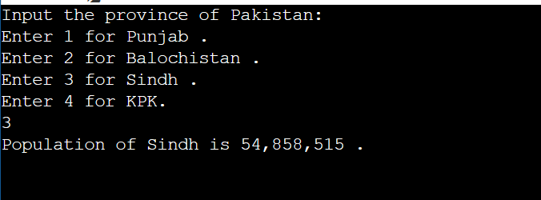

**Task:2**

#include <iostream>

using namespace std;

int main(){

//code checking for alphabets and consonants using cases.

char x;

int c;

cout<<"Input the alphabet."<<endl;

cin>>x;

if(x=='a'||x=='e'||x=='i'||x=='o'||x=='u'||x=='A'||x=='E'||x=='I'||x=='O'||x=='U')

{c=1;}

else{

if(x>='a'&&x<='z'||x>='A'&&x<='Z')

{c=2;}

}

switch(c){

case 1:

cout<<x<<" is a vowel."<<endl;

cout<<endl;

break;

case 2:

cout<<x<<" is a consonant."<<endl;

cout<<endl;

break;

default:

{cout<<x<<" is invalid."<<endl;}

break;}

return 0;}

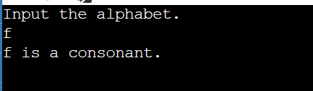

**Task: 3**

#include <iostream>

using namespace std;

int main(){

int number;

cout<<"Enter a number:";

cin>>number;

switch(number=0?0 : (number<0?-1:0 )){

case 0:

cout<<"number is zero.";

break;

case -1:

cout<<"number is negative.";

break;

default:

cout<<" number is positive. ";

break;

}

return 0;

}

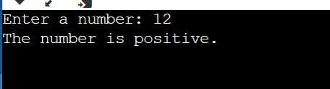

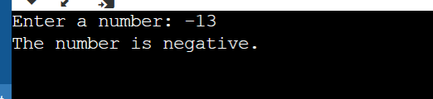

**Task:4**

#include <iostream>

using namespace std;

int main() {

int age;

cout << "Enter your age: ";

cin >> age;

if (age >= 18) {

cout << "You are an adult." << endl;

} else {

if (age >= 13) {

cout << "You are a teenager." << std::endl;

} else {

cout << "You are a child." << endl;

}

}

return 0;

}

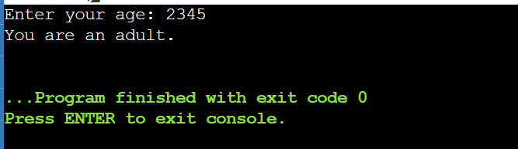



**Task:5**

#include <iostream>

using namespace std;

int main()

{

int num1, num2, num3;

cout << "Enter three numbers: ";

cin >> num1 >> num2 >> num3;

int greatest;

if (num1 > num2)

{

if (num1 > num3)

{

greatest = num1;

}

else

{

greatest = num3;

}

}

else

{

if (num2 > num3)

{

greatest = num2;

}

else

{

greatest = num3;

}

}

cout << "The greatest number is " << greatest << endl;

return 0;

}

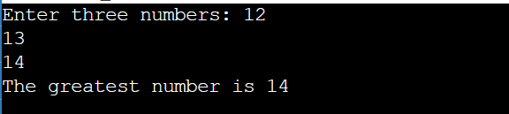

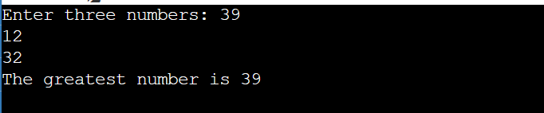

**Task:6**

#include <iostream>

using namespace std;

int main(){

char x;

cout<<"input alphabet."<<endl;

cin>>x;

cout<<endl;

if(x=='a'||x=='e'||x=='i'||x=='o'||x=='u'||x=='A'||x=='E'||x=='I'||x=='O'||x=='U')

{cout<<x<<" is a vowel."<<endl;}

else

{cout<<x<<" is a consonant."<<endl;}

return 0;

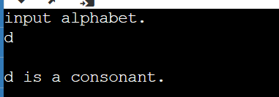



**THE END**